Week of April 24, 2022

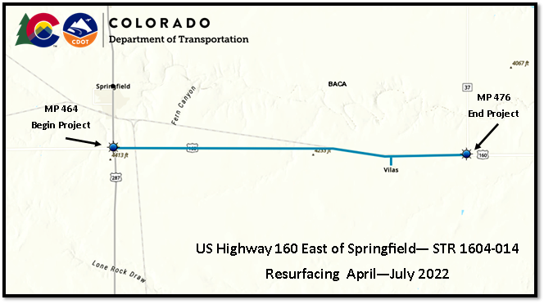
US 160 in East of Monte Vista

What Work is Being Done?

The project will ensure that current federal standards, with the Americans with Disabilities Act, are met and maintained for enhanced accessibility and pedestrian safety. Work will began on Monday, April 18 and is expected to be complete by October 2021.

This week crews will continue construction to upgrade curb ramps and sidewalks at various locations along US 160 in Monte Vista. A 12-foot width restriction is in place for oversize loads from Monday thru Friday, 7:00 AM to 7:00 PM. Speed reductions down to 25 mph can be expected as motorists come into Monte Vista. Flagging Personnel will be onsite due to alternating single lane closures. Expect up to 10 minute traffic delays. These closures and delays of US 160 will be in effect between April, 2022 and July 2022.

Why is the work being completed?

The project will ensure that current federal standards, with the Americans with Disabilities Act, are met and maintained for enhanced accessibility and pedestrian safety. “Improving the sidewalks and curb access will benefit Monte Vista’s business district and multimodal needs,” said Julie Constan, the Regional Transportation Director for southwest Colorado. “Complying with ADA standards will make certain all members of the community—whether on foot, wheelchair or bicycle—can easily and readily use highway crossings and intersection crosswalks.”

When will crews be working?
Work will take place during daylight hours, 7am to 7pm, Monday through Friday. Night work and weekend work are not anticipated at this time.

Travel Impacts

Alternating single lane closures on US 160 between MP 464 and MP 476 and on 4 miles of CO 100 between MP 0.0 and 0.4.

Width restrictions of 12 feet will be in place Monday thru Friday, 7:00 AM to 7:00 PM within the project boundary.
- Flagging personnel be on sight to direct travelers as the speed limit will be reduced to 25 mph while working in in town during daylight hours.

Project Contact Information
- Project Phone Line - (719) 480-9890
- Project email - jlopez@apc.us.com
- Project web site - https://www.codot.gov/projects/us160-co370-resurfacing
- Sign up for weekly project updates - Please log onto the project web site and fill out the right-side form to “Subscribe to Project Updates.”

For information on road work and travel conditions visit COTrip.org, sign up for travel alerts at Alerts, or call 511. Updates are also available via Twitter @coloradodot and CDOT’s Facebook page at Facebook.com/coloradodot.

